**Expert ID/Name: Nstructive**

**Date: 4-Nov-2020**

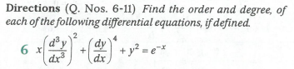

|  |  |
| --- | --- |
| Very Short Answer Questions | |
| Answer | |
| Given : Differential equation is .  To find : The order and degree of the differential equation |
| Explanation:-  Step :   |  |  | | --- | --- | | Instruction | **Order is the highest derivative occurring in the differential equation** | | Calculation | In this differential equation, highest order derivative is .  Order of  is. |   Step :   |  |  | | --- | --- | | Instruction | **Degree is the highest order derivative in the differential equation.** | | Calculation | Power of  is  Degree of  is . |     Verified Answer:-  Order =  Degree= |